Experiment 12
Firewall Configuration & Security Log Analysis

Lab 12 Objectives:
● Implement firewall rules to block/allow specific traffic and analyze security logs.
Prerequisites: The prerequisites of this lab are-
● Basic understanding of firewall concepts and network security.
● Familiarity with IP filtering, ports, and protocol-based rules.

Outcomes: By the end of this lab, students will be able to:
● Configure firewall rules to allow or block specific traffic.
● Monitor and analyze firewall security logs.
● Evaluate the effectiveness of firewall policies in securing a network.

Introduction
A firewall is a network security device or software that monitors and controls incoming and outgoing network traffic based on predefined security rules. It acts as a barrier between a trusted internal network and untrusted external networks, such as the internet. Firewalls filter traffic to prevent unauthorized access, attacks, and data leakage.
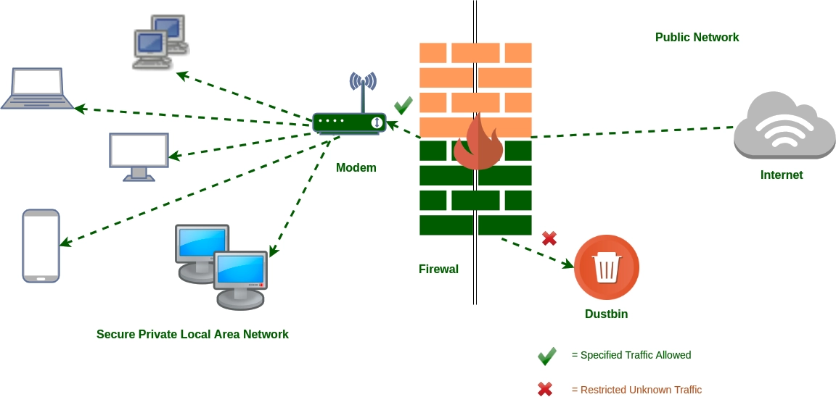

Experiment Description

- Setting up Firewall:
  - A firewall was configured using software tools like iptables, firewalld, or hardware firewalls like Cisco ASA.
  - The firewall acts as a gatekeeper by applying filtering rules to network packets.

- Defining Firewall Rules:
  - Rules were created to allow or block traffic based on:
    - IP addresses (source or destination)
    - Port numbers (e.g., HTTP on port 80, SSH on port 22)
    - Protocols (TCP, UDP, ICMP)
  - Examples of rules:
    - Allow incoming HTTP traffic on port 80.
    - Block incoming SSH traffic from unknown IPs.
    - Drop ICMP (ping) requests to prevent ping floods.

- Testing Firewall Behavior:
  - Attempts were made to connect using allowed and blocked protocols and ports to verify rule enforcement.
  - Tools like nmap were used for port scanning to test firewall defenses.

- Monitoring Firewall Logs:
  - Logs were monitored using tools like journalctl, logwatch, and fail2ban.
  - Logs show records of allowed connections, blocked attempts, and possible attack signatures.

- Analyzing Security Logs:
  - Log entries were analyzed to detect patterns such as repeated blocked attempts from a single IP (possible brute-force attack).
  - Suspicious activity was identified and documented.

- Documentation:
  - Firewall rules configuration, commands used, and their outputs were recorded.
  - Security log excerpts highlighting blocked and allowed traffic were saved.
  - Analysis report was prepared on firewall effectiveness.

Firewall Concepts and Rule Types

- Default Policies: Firewall default action for incoming and outgoing traffic (allow or deny).
- Allow Rules: Explicitly permit traffic matching criteria.
- Deny/Drop Rules: Block traffic that matches rule conditions.
- Stateful Inspection: Tracks connection states to allow returning traffic for established connections.
- Logging: Records all allowed or blocked packets based on rules for audit and analysis.

Tools Used

- Firewall Software:
  - iptables: Command-line tool for Linux firewall management.
  - firewalld: Dynamic firewall daemon with zone support.
  - UFW (Uncomplicated Firewall): Simplified iptables interface.
  - pfSense / Cisco ASA: Dedicated firewall appliances.

- Log Analysis Tools:
  - journalctl: For viewing system logs in Linux.
  - logwatch: Summarizes log files and detects anomalies.
  - fail2ban: Automatically bans IPs with suspicious behavior.

- Network Tools:
  - netstat: Displays network connections and listening ports.
  - tcpdump: Captures network packets.
  - nmap: Network port scanner.

Example Firewall Rules
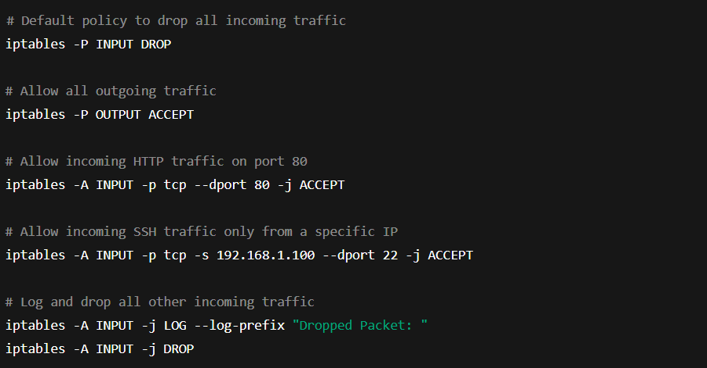

Firewall Log Analysis
- Logs typically contain:
  - Timestamp of event.
  - Source IP address of incoming request.
  - Destination port and protocol.
  - Action taken (ACCEPT or DROP).
  - Example log excerpt:
- By analyzing logs, we can:
  - Detect repeated unauthorized access attempts.
  - Identify scanning or brute force attacks.
  - Confirm legitimate access is allowed.

Observations
- Firewall successfully blocked unauthorized access attempts on blocked ports.
- Allowed traffic on open ports passed without interruption.
- Logs clearly showed blocked IP addresses, helping in further security decisions.
- Performance impact due to firewall was negligible for normal traffic levels.

Security Threat Detection via Firewall Logs